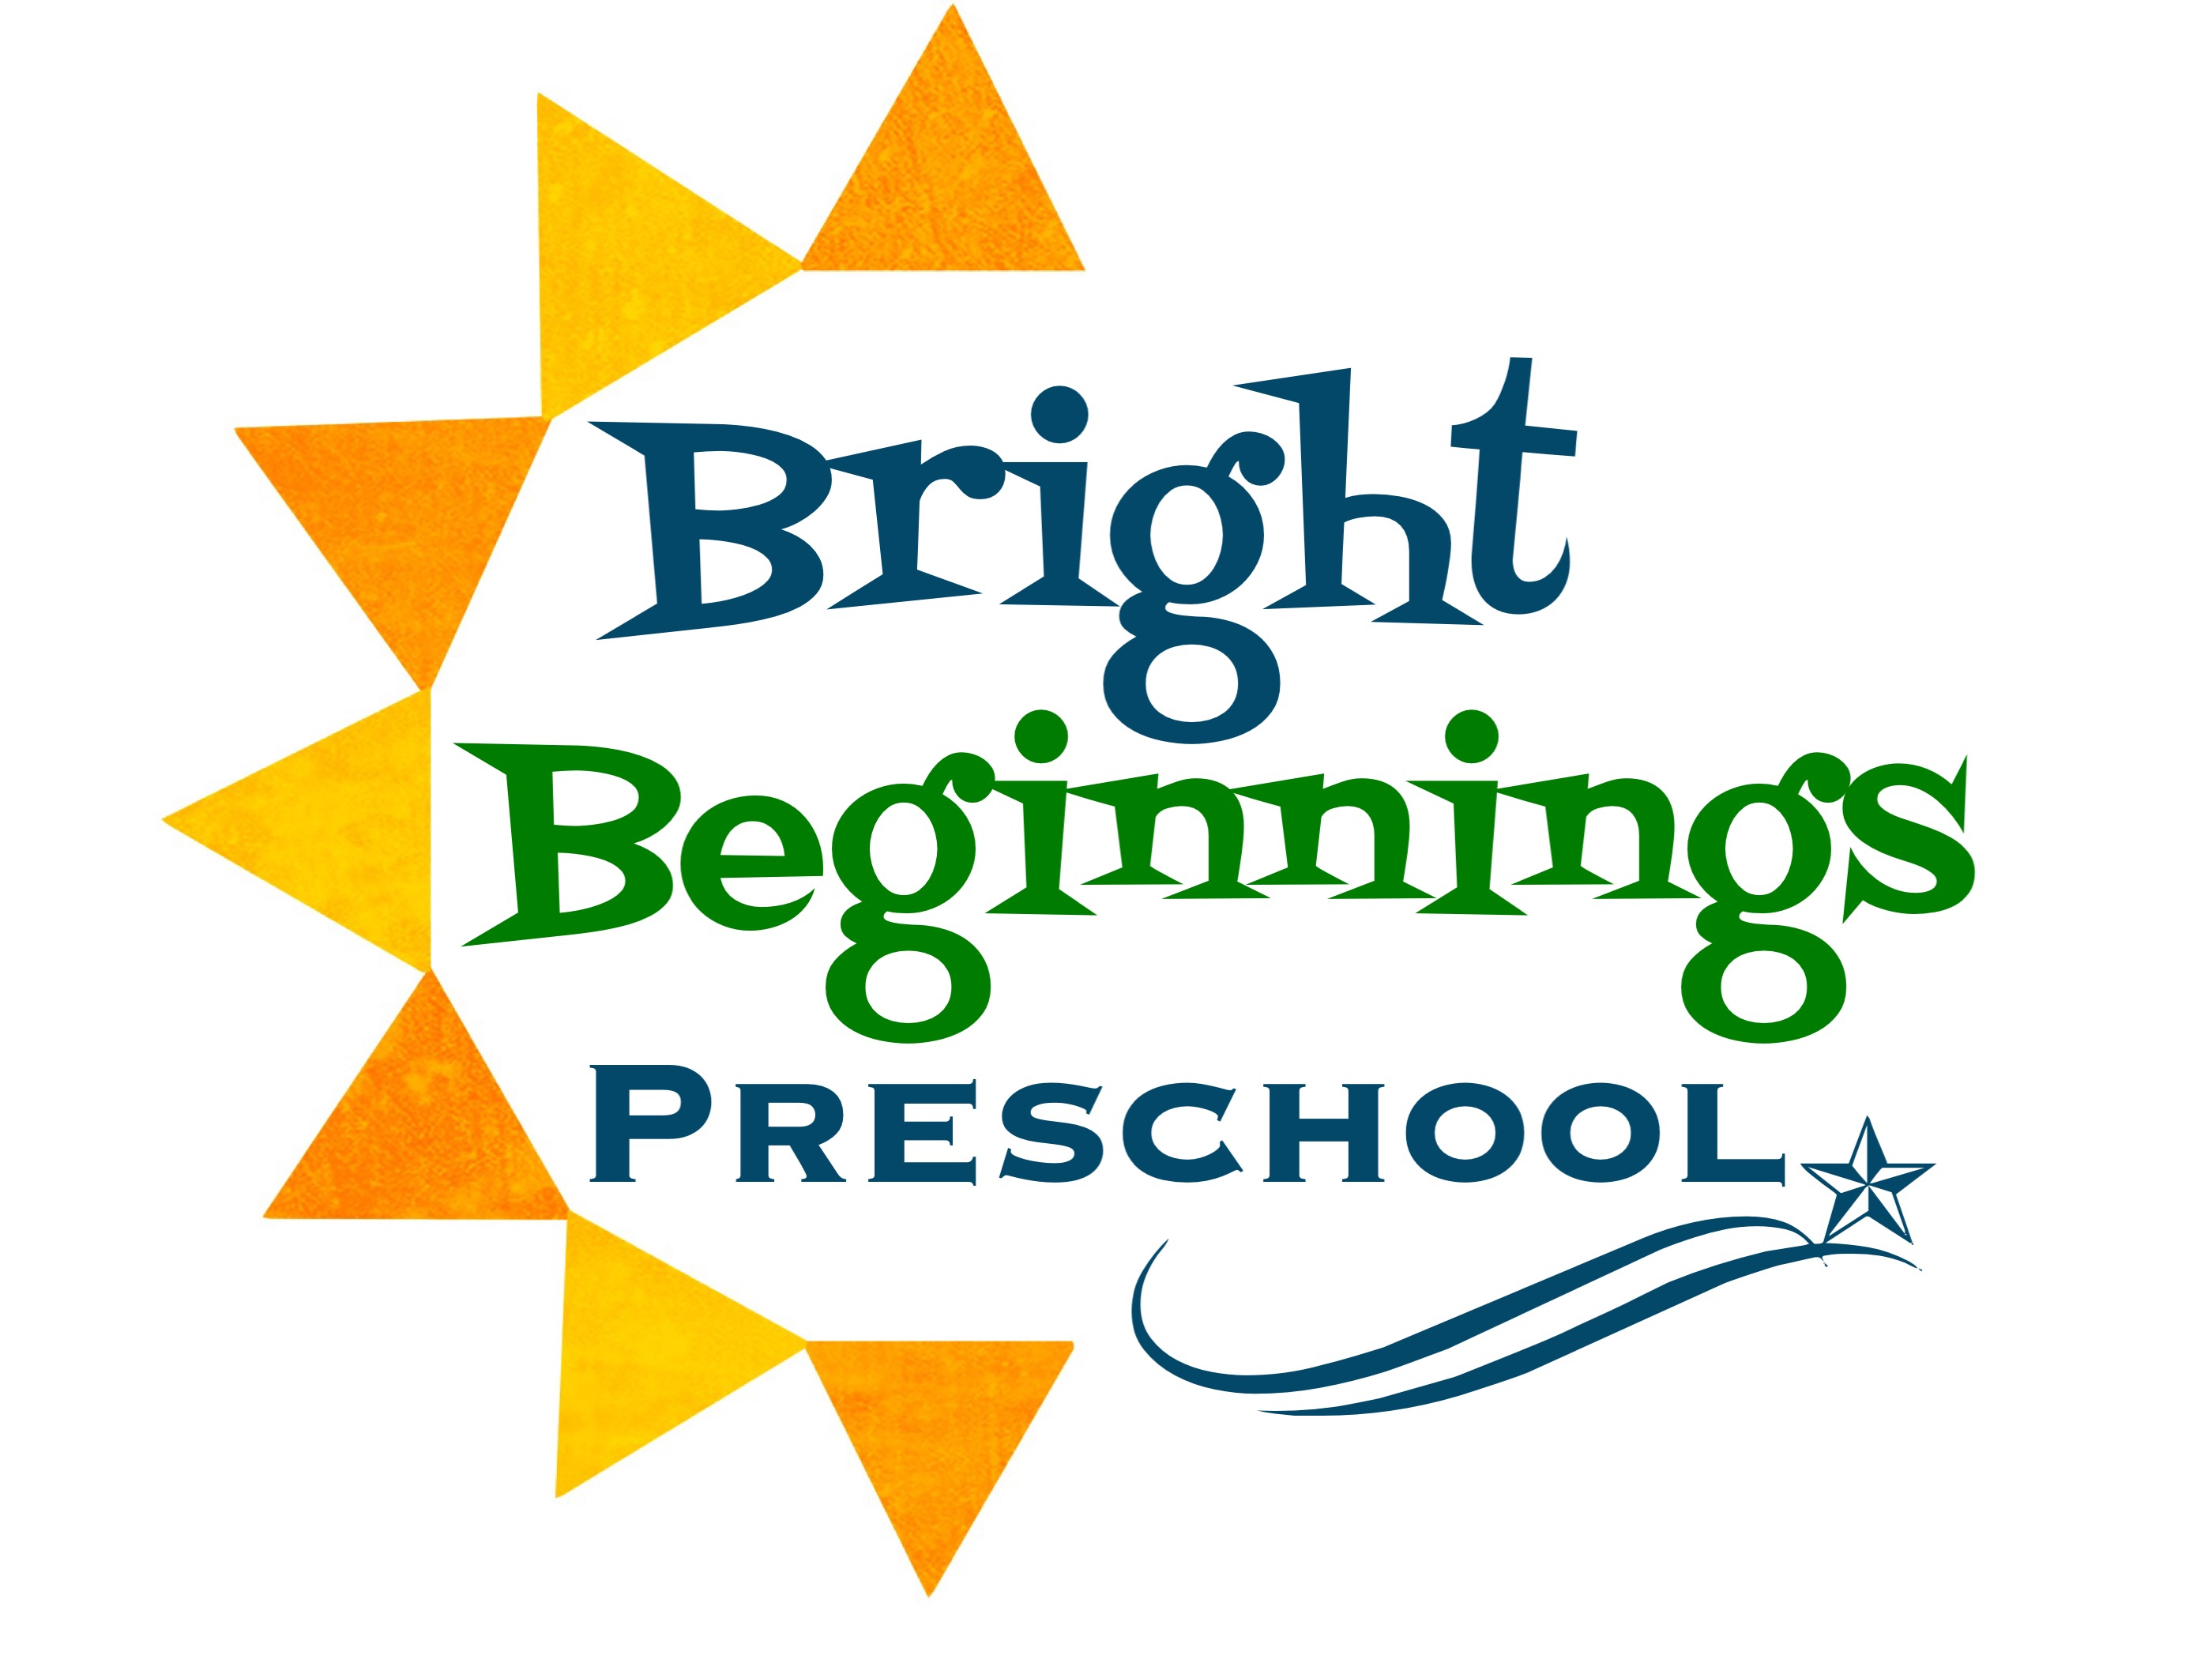

We are a premier Christian school with the highest quality of education to start children on the right path in school and life.

Parent Handbook
2022/2023

Dear Parents and Caregivers,

Welcome to Bright Beginnings Preschool! We are happy to provide your child with a safe and caring Christian preschool. This handbook provides you with information about our program. If you have concerns, which are not addressed, please feel free to contact me. We value your involvement in our program and look forward to working with your family this year. Thank you for choosing Bright Beginnings as your child’s preschool.

Please watch bulletin boards or newsletters for special events and new information.

Mission
Bright Beginnings is a child-centered, family-focused preschool committed to developing and preparing the whole child for learning and their transition into kindergarten.

Values
Families: We respect parents as the child’s first teachers and collaborate with them to grow in their abilities to be child educators at home, school, church and in their community.
Community: We are a Christian family welcoming those we serve.
Environment: We strive to provide a safe, warm and loving learning environment where their individuality can be supported and nurtured.
Christian: We build faith through Christ-centered learning in a wholesome environment.
Curriculum: We believe success in school and in life depends on developing the whole child physically, socially, emotionally, cognitively and spiritually through developmentally appropriate curriculum.

Nondiscrimination Policy
Bright Beginnings Preschool prohibits discrimination against any person in either admission to the program or services available on the basis of:
- Race
- Color
- National origin
- Sex
- Religion
- Presence of physical, sensory or mental disability
This preschool does not discriminate against children, families or staff with disabilities. Children, families and staff with physical, sensory or mental disabilities are encouraged to participate in all the activities and opportunities at the preschool. We assess children on an individual basis to determine whether a child with special needs can be cared for at our preschool with reasonable accommodations.
We are committed to treating all families with dignity and respect for their individual needs and differences.

Tuition/Payments
Tuition is calculated for 10 months and divided into 10 equal monthly payments. You are not charged for days missed due to holidays.

Number of days Monthly Annually
2-day class $195 $1950
3-day class $245 $2450
4-day class $295 $2950
*Tuition assistance is available

Admissions
Registration the 2023-2024school year begins in February 2020.

Fees
Bright Beginnings collects an $85 registration fee each year.

Payments
Parents may choose to pay for the entire year or pay monthly. Tuition is due by the 15th of each month. If payment is not received by the 15th of the month a 10% late fee will be added to your child’s tuition that month. Please drop payment off in the tuition box in the office or pay online. If payment is 30 days past due, your child will not be permitted back in class until balance is paid or your child’s seat may be given to a child on the waiting list.

Absences
If your child will be absent, please let us know. Tuition is based on days offered not the number of days you attend. We do not offer make up days.

Withdrawal from program
You must notify the director by the 15th of the preceding month in order to withdraw your child from the program and not incur a cost for the next month. Withdrawals during a month will not result in a refund.

Hours
Morning drop off is 8:45-9:00am and pick up is 12:30pm.

Drop off and pick up procedures
A parent or guardian must be present to sign in the child each day. Please have your child use the hand sanitizer as they enter the classroom. Pick up for the Owl classes will be at the front door. The Hedgehogs will pick up at the backdoor of their classroom. Raccoon classes will be picked up on the east side of the building and the Squirrel class may be picked up on the west side of the building. The Bear class may also be pick up on the west side of the building.

Late pick up fees
Parents must pick up students within 10 minutes of the end of class time. If you have an emergency, please call the director as soon as possible. An $8 per 15-minute late fee will be accrued for additional staff time. Late pick up fees must be paid by cash or check prior to the next scheduled school day. Continual tardiness will result in your child’s removal from the program.

Release authorization
Children will only be released to a parent or authorized person as identified in the dismissal authorization section of the registration form. Should an unauthorized person need to pick up your child, please notify the director/teacher. Please note: a driver’s license will be required for identification.

School closure announcements
Weather conditions may warrant school closure from time to time. We will follow the Evergreen School District closures. If there is a two-hour late start, we will be closed.

Snow days
If a class is cancelled for more than 3 days, make up days will be added in June.

Security procedures
All preschool exterior doors and fences remain locked during school hours. Should you need to access the building, please use the church office entrance. Church and preschool staff may access the preschool area through other doors. In the event of an emergency we have the ability to lock down the preschool area.

Emergency care
In the event of a natural disaster or a major emergency, staff will remain with the children until you or an emergency contact can safely travel to pick up your child.

Drills
Emergency drills are held several times a year in each classroom. Children will learn where to go during a lock down procedure and how to exit the building in case of a fire evacuation.

Illness
For the protection of all children and staff, your child must be kept at home if any of the following symptoms were present within the last 24 hours:
- Fever over 101 degrees
- Diarrhea
- Vomiting
- Nausea
- Severe cough
- Eye discharge or conjunctivitis (pink eye)
- Unusual yellow coloring to skin or eyes
- Skin and eye lesions or rashes
- Stiff neck and headaches with one or more of the symptoms listed
- Difficulty breathing or wheezing
- Complaints of severe pain
- Lice or scabies (until no nits remain)
- Fatigue that prevents participation in regular daily activities

Children who show signs of the above illnesses will be removed from the classroom and parents will be asked to pick their child up from preschool. If your child has an outbreak of a communicable disease, please keep him/her home and notify us immediately.

Medications
The preschool is not in a position to store or administer medication to children. Please administer all medication to your child prior to arriving.

Emergency medications
If your child has a medical condition which might require medicine for an emergency (such as a bee sting or asthma) we will keep these on hand as long as the appropriate forms are completed. A teacher will store it in a locked drawer or cabinet.

Injury
For all injuries requiring any medical care (icing, Band-Aids) staff will administer first aid and complete an accident report which you will receive a copy of. In the event of a medical emergency we will contact 911 and you as soon as possible. If we are unable to contact you, the emergency contacts on your registration form will be notified. In the event your child requires transportation to the hospital before you arrive, a staff member of the preschool will accompany your child.

Immunizations
Washington State Law (RCW 28A.210.160) requires that all children have a WA certificate of immunizations status on file before the first day of school or fill out a certificate of exemption.

Allergies
Please notify the director and update your file if your child develops an allergy to any foods or is no longer allergic to a food that you have listed in the registration packet. This information will be kept in the student’s file and also posted in each classroom to assist with snack time.

Lunch
Children should bring their own lunch to school each day. We will work with each child on the skills necessary to have a successful lunchtime experience. If you forget your child’s lunch one will be provided, and you will be charged $5. If your child is in our afternoon program, no lunch is needed.

What to wear
Children should be dressed in casual clothing which:
- Allows for a full range of movement and comfort
- Allows the child to dress/undress self easily for bathroom use
- May become wet and dirty
Shorts or leggings must be worn under dresses/skirts at all times.

What to bring
Please send your child to preschool each day with a bag or backpack which includes a change of clothing. Please make sure all items are labeled including backpack, jacket and sharing day items.

Sharing day
Teachers will designate a share day for each child.

Curriculum
The Creative Curriculum is a nationally recognized framework for planning and implementing developmentally appropriate practice in early childhood settings. It is an effective way to help children acquire social competence and the skills they need to succeed as learners.
We are early learning partners with the Evergreen School District.

Daily schedule
A daily schedule, monthly calendar and newsletter are posted in each classroom or appropriate bulletin board. Every month a newsletter and calendar will be sent home.

Chapel
Once a week the children go to chapel. During this time, they sing songs, pray together and listen to a short devotional story that goes along with their Bible story and character quality studies in class. All chapel leaders have had appropriate background checks.

Recess
In order to keep our playground safe, we have adopted the following:
- Climbing is only permitted on the play structure
- Children may not climb up the big slides and must sit when sliding
- No throwing bark chips or rocks
- Bike helmets must be worn at all times
- Two teachers are with children at all times

Birthday celebrations
Store bought birthday treats are welcome, but please make arrangements with your child’s teacher in advance. Please do not bring party invitations to school to be passed out by the teacher unless you have one for everyone.

Volunteers
Volunteers must be 18 years or older and must have a background check. You must work out times with your child’s teacher and are not allowed to bring additional children for volunteer activities. Bright Beginnings does reserve the right to refuse volunteers. Opportunities exist for those who would like to volunteer their time outside of the classroom.

Parent visits
For the orderly running of the classes we would ask that you schedule visits to the classroom.

Teacher/Parent conferences
Conferences are available upon request.

Staff
The staff is referred to as Miss <first name> or Mr.<first name>.
All of the teachers hold a current certification in CPR and First Aid and have completed a class on blood-born pathogens and AIDS. All teachers/assistants have passed a background check.

Reporting abuse
State law requires all teachers to report all suspected cases of child abuse or neglect. This is anything that might endanger the health, well-being and welfare of children.

Photos
Photos and video of students are taken as part of the program. These may be shared with parents, posted in the building, included in class projects and used for church ministry.
School/class photos will be taken in the fall.

Discipline policy
Disciplinary methods used shall be based on guidance techniques to help the child develop inner control, self-responsibility and respect for others. Under no circumstances will corporal punishment be used.
While we must set behavior limits, we intend those limits to benefit the child rather than make things convenient for adults. We cannot allow children to injure themselves, others or destroy property. We reserve the right to refuse service to children who, despite corrective action, continue disruptive or unsafe behavior patterns.

Biting
If a biting incident occurs, we will work with parents/child and teachers in the classroom to correct this behavior. If the behavior continues we reserve the right to remove the child from the school for the safety of the other children.

VanChurch
Bright Beginnings Preschool is an active ministry of the Vancouver Church of Christ. If we can help your family in any way, please let us know. We would love to have you join us any Sunday.

10:00am Sunday morning
- Nursery & Bible classes for children
- Teen classes
- Adult classes
Sunday morning worship
9:00am Traditional or 11:15am Contemporary
- Nursery
- Rock Solid Kids
- Worship

Mothers of Preschoolers (MOPS)
MOPS is a group of mothers who get together for fun, fellowship, learning and sharing. They meet Wednesday mornings from 9:00am to 11:00am. Childcare is provided.

Contacts:

Bright Beginnings Preschool
www.brightbeginningspreschool.org
Christina Hill, director
(360)882-3496

VanChurch
www.vanchurch.org
(360)696-0548

